 | 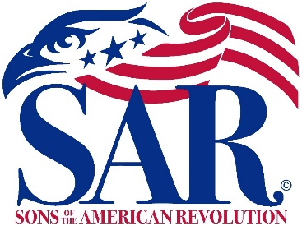 | 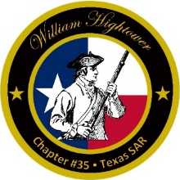

William Hightower Chapter
Texas Society, Sons of the American Revolution
Patriotic-Historical-Educational

Meeting Agenda
12 Jan, 2023
Social Hour: 5:30 p.m. Business: 6:30 p.m.
Granzin Bar-B-Q, New Braunfels

- Invocation
- Pledges to the Flags
  - Pledge of Allegiance
  - Texas State Pledge
  - SAR Pledge
- Introduction of Guests
- President’s Welcome and Comments
- Officer and Committee Reports
- Program for the upcoming year
- Next Meeting
9 Feb 2023, Social Hour 5:30 p.m., Business 6:30 p.m.
At Granzin Bar-B-Q
- Benediction
- SAR Recessional

